**CTF Challenge: Binary Analysis**

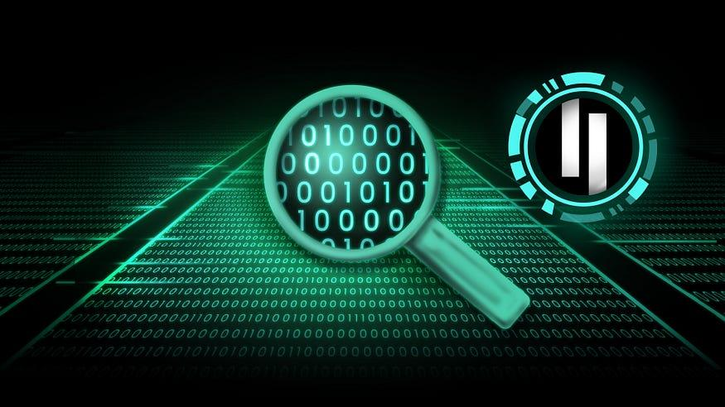

**Why to Perform Binary Analysis?**

There are several reasons why someone might perform binary analysis:

* **Vulnerability Hunting:** Security researchers use binary analysis to identify vulnerabilities in software. These vulnerabilities could allow attackers to gain unauthorized access to a system or steal sensitive data.
* **Malware Analysis:** Understanding the behavior of malware is crucial for developing effective security solutions. Binary analysis allows researchers to dissect malware code and understand its functionalities.
* **Hidden Feature Discovery:** Sometimes, developers embed secret flags or features within the binary code for internal testing or debugging purposes. Binary analysis can help uncover these hidden elements.
* **Reverse Engineering:** As discussed previously, binary analysis is a fundamental aspect of reverse engineering. By disassembling and analyzing the code, you can understand how a program works, even without its source code.

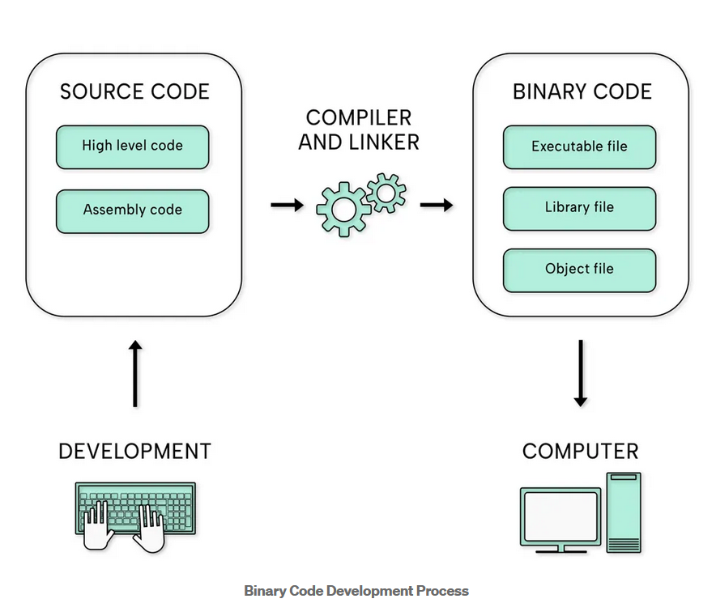

**Techniques of Binary Analysis:**

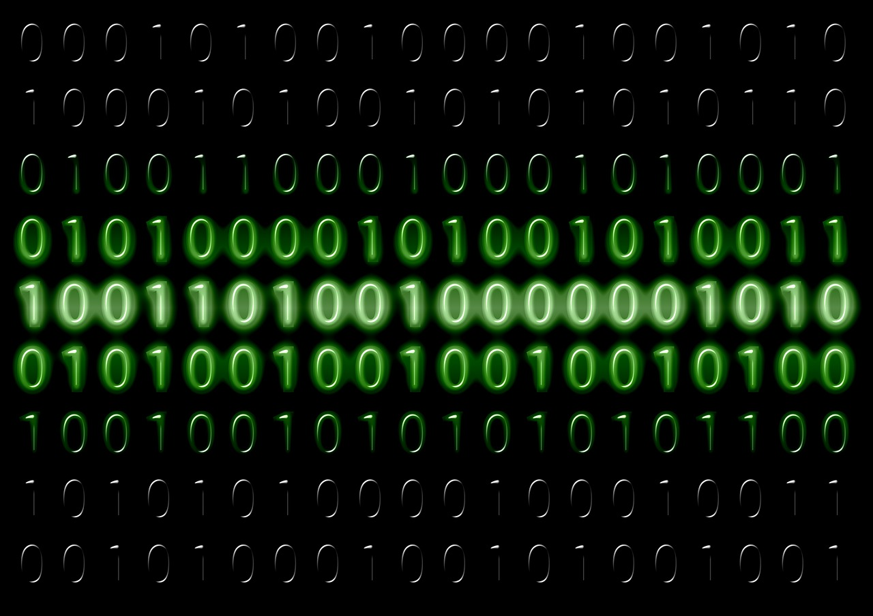

Binary analysis involves various tools and techniques:

* **Disassembly:** This is the heart of binary analysis. It translates the raw binary code into a more human-readable assembly language format. This allows you to see the program's instructions and understand its basic logic flow.
* **Decompilation:** While not always perfect, decompilation attempts to recover the original source code from the binary code. This can provide a higher-level view of the program's structure and functionality.
* **Static Analysis:** This technique involves examining the binary code without actually running the program. Static analysis tools can identify potential vulnerabilities, suspicious code patterns, and embedded strings or data.
* **Dynamic Analysis:** In contrast, dynamic analysis involves running the program in a controlled environment and monitoring its behavior at runtime. This allows for a more in-depth analysis, uncovering vulnerabilities that might not be apparent through static analysis alone.

**Challenges of Binary Analysis:**

Binary analysis is not a walk in the park. Here are some obstacles you might encounter:

* **Obfuscation:** Just like with reverse engineering, programmers may intentionally obfuscate their code to make it harder to analyze. This can significantly increase the difficulty of understanding the code's functionality.
* **Lack of Information:** Sometimes, there's limited or no documentation available for the program you're analyzing. This can make it more challenging to interpret the code and identify vulnerabilities.
* **Anti-Analysis Techniques:** Some software might have built-in mechanisms that detect and thwart binary analysis attempts. These techniques can require advanced knowledge and tools to bypass.

# **Capture the Flag (CTF) Challenges**

Flag 1. Security researchers use binary analysis to identify what in software?

Answer: Vulnerabilities

Flag Captured

Flag 2. What translates raw binary code into a more readable format?

Answer: Disassembler

Flag Captured

Flag 3. What technique examines code without actually running the program?

Answer: Static

Flag Captured

Flag 4. What process involves running the program to monitor its behavior?

Answer: Dynamic

Flag Captured

Flag 5. Programmers might obfuscate code to make it harder to do what?

Answer: Analyze

Flag Captured